Project Design Phase-II
Data Flow Diagram & User Stories

Date | 18 February 2026
Team ID | LTVIP2026TMIDS79720
Project Name | Advancing Nutrition Science through Geminiai
Maximum Marks | 4 Marks

Data Flow Diagrams:
A Data Flow Diagram (DFD) is a traditional visual representation of the information flows within a system. A neat and clear DFD can depict the right amount of the system requirement graphically. It shows how data enters and leaves the system, what changes the information, and where data is stored.

Example: (Simplified)
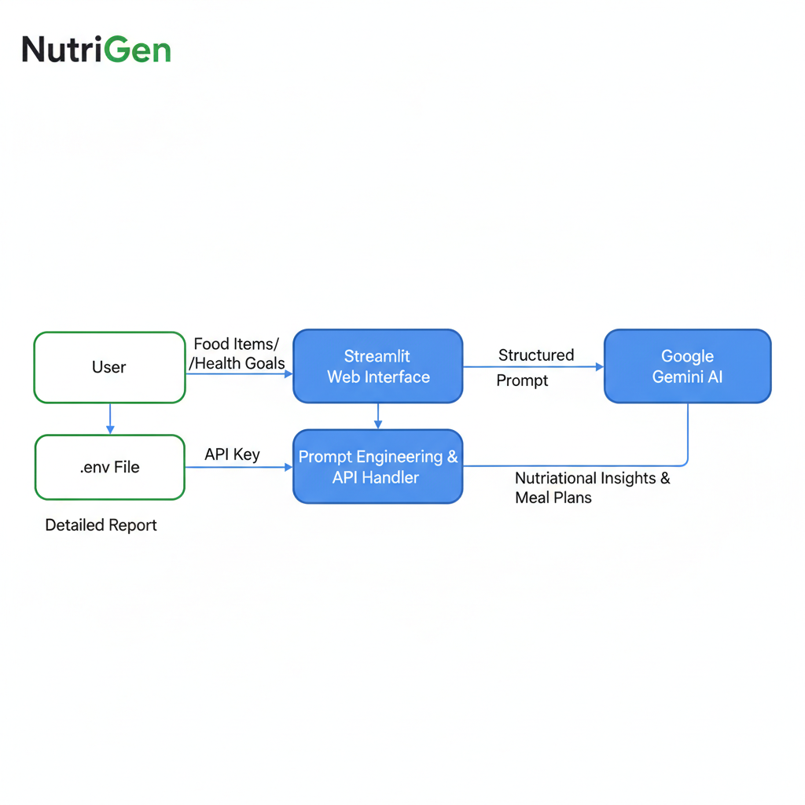

User Stories
Use the below template to list all the user stories for the product.
User Type | Functional Requirement (Epic) | User Story Number | User Story / Task | Acceptance criteria | Priority | Release
Customer (Web user) | Dynamic Insights | USN-1 | As a user, I want to input food items so I can see calories, macros, and a health verdict. | The UI displays a report with bold headings for each food item entered | High | Sprint-1
Customer (Web user) | Personalized Nutrition | USN-2 | As a user, I want to input my profile to receive a custom 7-day meal plan. | A full 7-day plan with meals and a grocery list is generated. | High | Sprint-1
Content Creator | Educational Output | USN - 3 | As a nutrition blogger, I want detailed micronutrient data to create educational content. | Responses include vitamins and minerals for every food item analyzed. | High | Sprint - 2
Content Creator | Coaching  Content | USN - 4 | As a virtual coach, I want to ask nutrition questions to provide evidence-based answers | The coaching interface provides expert-level responses to complex queries. | Medium | Sprint- 2
All Users | Engagement (UX) | USN - 5 | As a user, I want to see a loading spinner while the AI is thinking so I know it is processing. | A visible spinner appears during the API call (e.g., "Consulting AI Coach..."). | Medium | Sprint -2
All Users | Navigation | USN - 6 | As a user, I want a sidebar menu to switch between the three different scenarios. | A Streamlit sidebar exists with options to switch tools seamlessly. | Medium | Sprint- 1
Administrator | Security | USN - 7 | As an admin, I want to manage API keys via environment variables to prevent unauthorized access. | The app loads only if a valid .env file with the API key is present. | High | Sprint -1

